# Workstations and panels

## Introduction

Each FT NavVision© system consists of at least two full workstations. Mostly they are situated in the Wheelhouse and in the Engine room. These workstations, also called servers, will have the alarm screen with duty selection. When you click on the alarm icon in the taskbar it will show the “duty and Alarm mimic” (see Figure 8‑1).

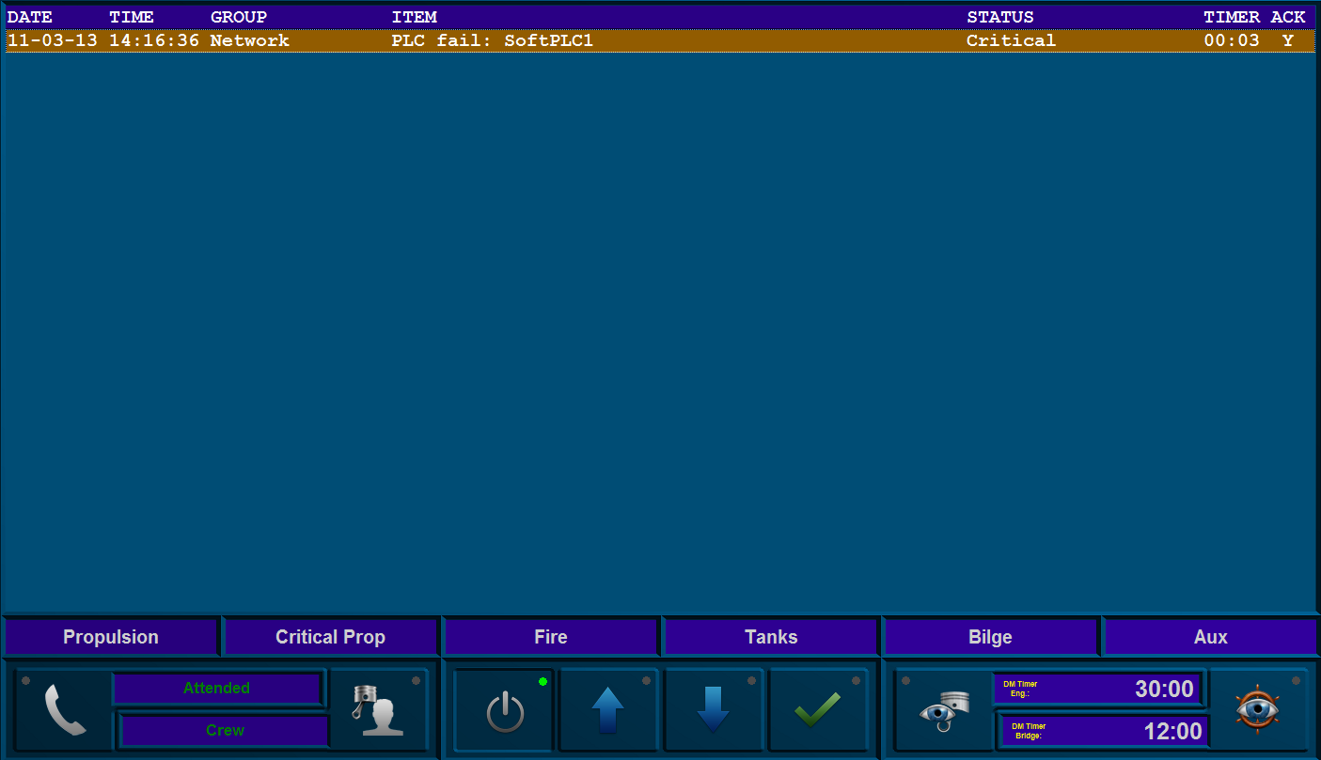

Figure 8‑1: Alarm screen Workstation

In smaller spaces FT NavVision© often use DAP’s (Duty Alarm Panels) which can be used to see and act upon alarms (see Figure 8‑2). These DAP’s have less functionality than a normal workstation. They are solely meant to show the alarms on an active panel. It is possible to determine which alarms will show here in the Alarm Matrix.

In a mess room and other public spaces workstations that are configured as client can be used so you can also see mimics etc. (see Figure 8‑1).

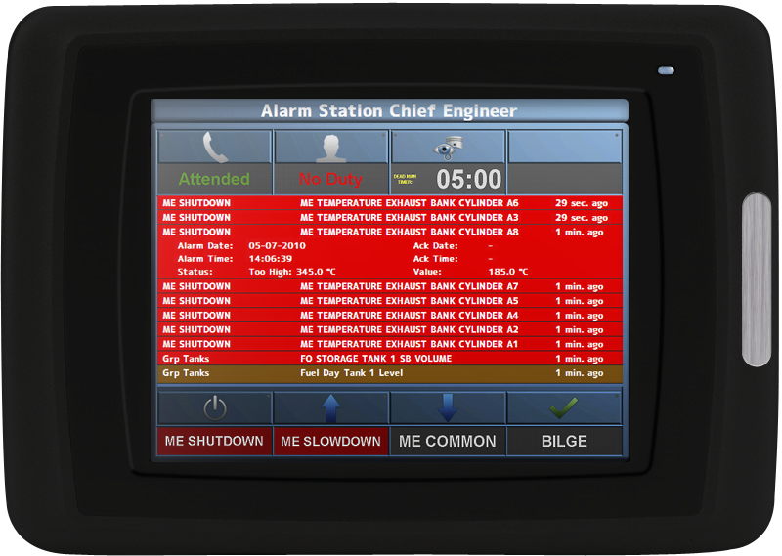

Figure 8‑2: Duty Alarm Panel

If we don’t need a workstation and a DAP is still too big or too expensive, FT NavVision© can place an Alarm Panel. These Alarm Panels are metal plates accommodated with different kinds of buttons and most likely a buzzer (see Figure 8‑3).

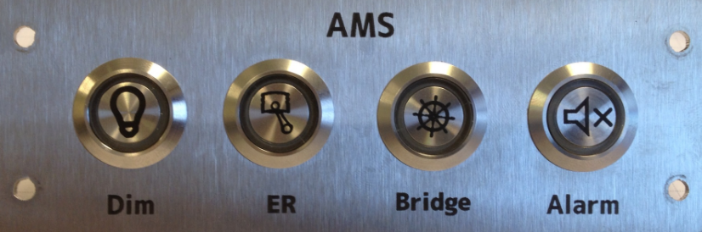

Figure 8‑3: Alarm Panel (Typical)